

**corPatch Adult Therapy Electrodes 05120.5**

**Change Notice**

**The corPatch therapy electrodes have been optimised by**

**the manufacturer.**

There may be 2 versions of the **ADULT** therapy electrodes circulating.

Below are the physical differences between the **old** and the **new** therapy electrodes.

New Adult

Therapy Electrodes

Rev: BA00000001

Previous Adult Therapy Electrodes

Rev: AA00000001

### 

* Improved pictogram of ADULT therapy electrode placement, LA & LL labelling removed
* Pictogram of therapy electrode placement for paediatric patients
* Sealed pouch
* Smaller adhesive surface
* Mesh incorporated into the gel to prevent residue from remaining on the skin

* Pictogram of ADULT therapy electrode placement
* LA & LL labelling
* Zip pouch

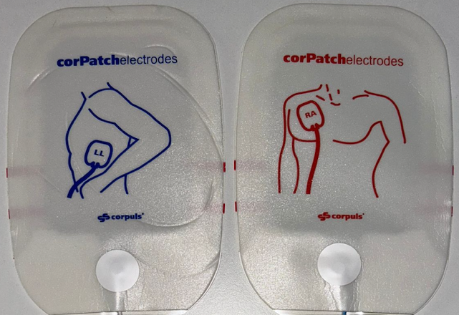

**No change in practice is necessary.**

Both styles of Adult Therapy Electrodes may be used for paediatric patients over 20kg. However, we recommend using corPatch paediatric electrodes for paediatric patients up to 25kg.

*corPatch Easy Paediatric electrodes automatically limit the energy to a maximum of 100J.

**See the following page for more images**

**corPatch Adult Therapy Electrodes 05120.5**

**Change Notice**

